**Date:** 05.05.2019

**Attendees:** Furkan Karakaya, Mesut Uğur, Ozan Keysan ☺

**Location:** Electrical Machines Laboratory

**Target:** V1.3 Gate Driver Board (#1)

**Test type:** Inverter test with RL load

**Aims before the test:**

**1.** Efficiency and thermal data measurement for all loading conditions

**Conditions:** 22 Ohm Ron, 2 Ohm Roff. 300V VDC. RL Load: Five different stages. 40kHz fsw. 0.9 power factor. Sinusoidal PWM with 0.9 modulation index.

**Steps:**

1. For all loading conditions (load step 1 to 5, where 5 is around 2kW), simultaneous voltage and current measurements are taken for:
   1. PhaseA
   2. PhaseB
   3. PhaseC
   4. DC

Voltage measurement is taken by HV probe (CH1). Current measurement is taken by 2 shunt resistors (CH2-a1 and CH3-a2). Resistance data is in appendix.

1. For full load, temperature vs time is taken with 5 min. steps.
2. For all loading conditions (load step 1 to 5, where 5 is around 2kW), steady state temperature data is taken.

**Results:**

Heating curve at full load Maximum temperature against load

** **

Thermal camera

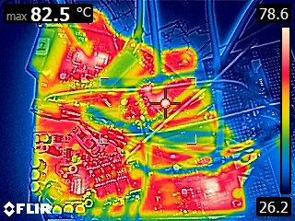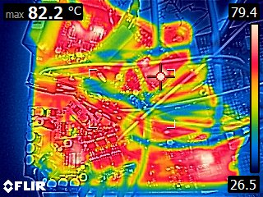

Efficiency

**Next time:**

TODO

**Appendix:**

Shunt resistance data:

|  |  |
| --- | --- |
| Resistor | Resistance |
| a4 | 101.735 mΩ |
| a3 | 101.934 mΩ |
| a2 | 100.055 mΩ |
| a1 | 101.878 mΩ |